Muhammad Izham Bin Norhamadi  
B032020039

**Task 1**

1. What is the full name of your targeted friends

- Ahmad Sha Herizam Bin Tahir

2. Your friend IC/social security number

- 000712011681

3. Email or phone number

- https://www.instagram.com/aaaaahmadz/

4. Your friends family member(parents, uncle, siblings and etc)

- Sister: Amira Teoh, Nainie Mohd Ali  
  
5. Your friends previous school

- SMK Pasir Gudang  
  
6. Hobby

- watching anime

**Task 2**

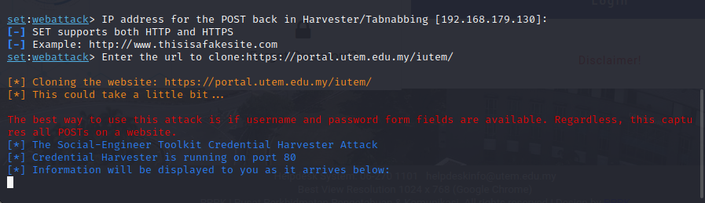

**Figure 1 Cloning Website using Social Engineering Toolkit**

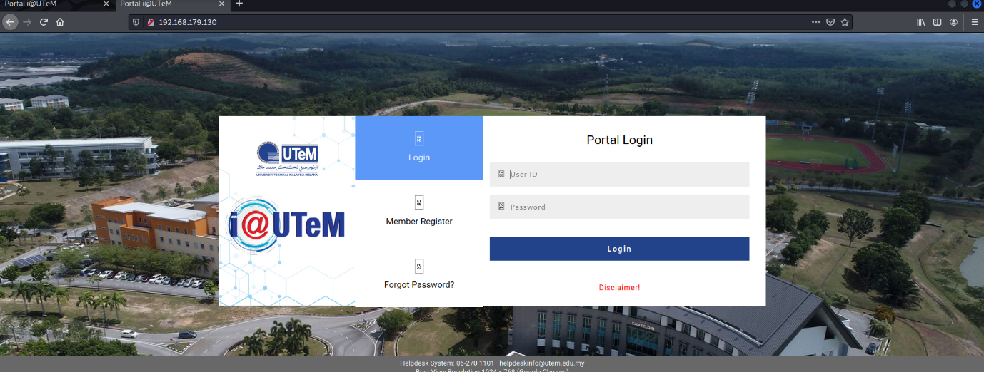

**Figure 2 Cloned UTeM Portal site**

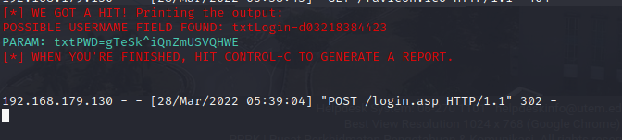

**Figure 3 Extract login credential from attempt**